EXPERIMENT -14
Hypothetical using ANOVA Test
Aim:
To compare the growth rates of plants under three different fertilizer
treatments(Treatment A,B,C) to determine if there is a significant
difference in their mean growth.

Procedure:
1. Null hypothesis
2. Alternative hypothesis
3. Sample
4. ANOVA
5. Decision Rule

Program:
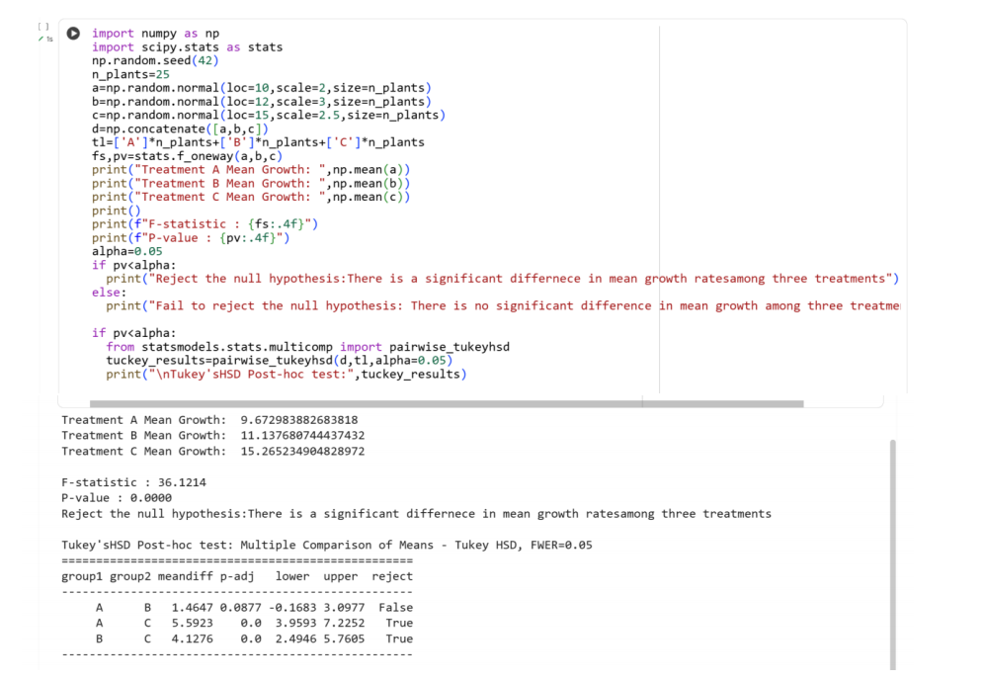
Result:
Thus the python program for hypothetical using ANOVA test is executed and output verified successfully

